SQL

DAY-6 ASSIGNMENT

09/12/2023

BY MIHIR KUMAR

SQL PROCEDURE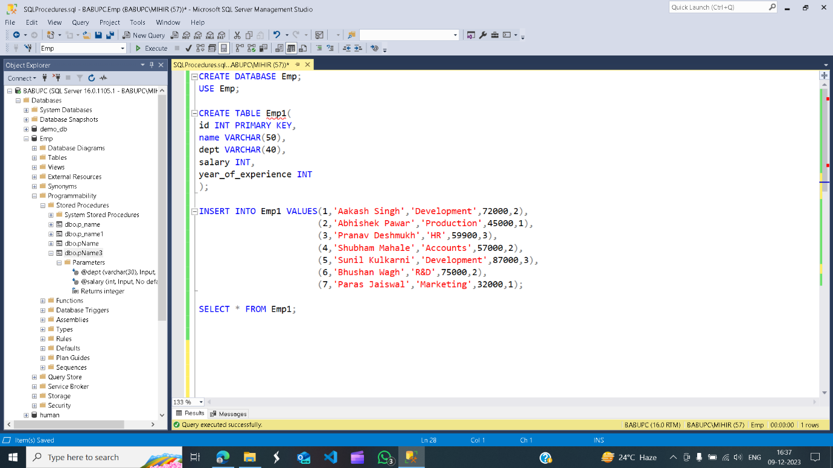

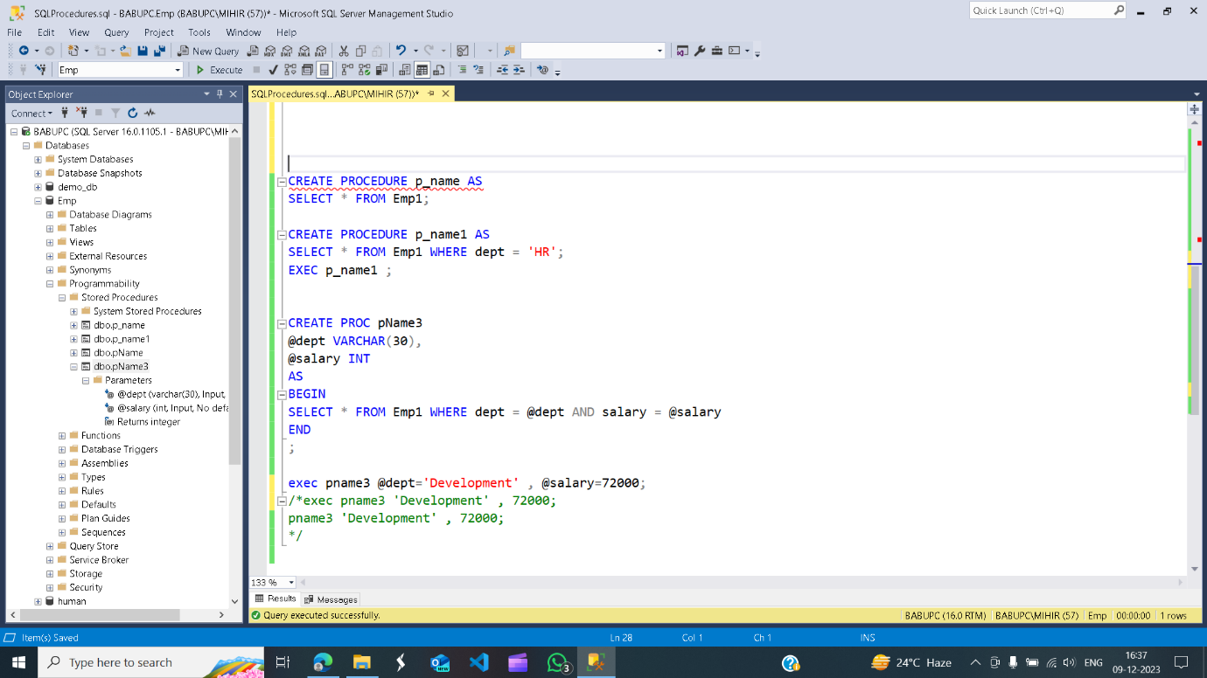

SQL SCHEMA

